**IB Biology** Name ____________________

**Topic 6.1 Study Guide** Date _____________________

**Please answer these questions COMPLETELY on a separate sheet of paper.**

**For Topic 6.1, you should be able to…**

1. Draw an annotated diagram of the human digestion. *Annotated* means you should write a brief description of the function of the structure next to its label. Make sure to include the following organs: mouth, esophagus, stomach, small intestines, pancreas, liver, gall bladder and large intestines. Use the diagram below to guide your drawing.

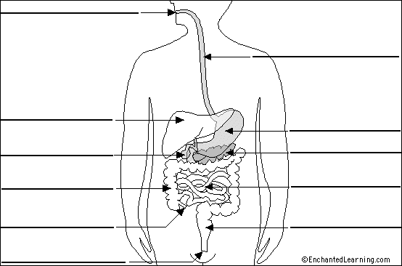

1. Identify the following tissue layers in the micrograph of the transverse section of the small intestine shown below: lumen, longitudinal muscle, circular muscle, mucosa and epithelium.

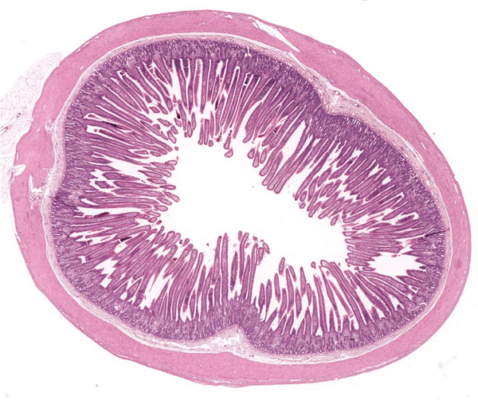

4

5

3

2

1

1. Define *peristalsis* and explain the roles of circular and longitudinal muscle in moving food along the digestive tract.
2. Describe the function of the pancreas in digestion.
   1. What are the three main groups of enzymes that it secretes?
   2. What macromolecules to each of these enzymes help to digest?
3. Identify the other source of enzymes in the small intestines (besides the pancreas). What is the role of these enzymes?
4. Identify one substance that humans cannot digest. Why are the unable to digest this substance?
5. Explain the role of villi in digestion. What are they? Where are they found? What do they do?
6. Using the word bank, identify the parts of the villus shown below. Describe the role of each part in the absorption of nutrients.

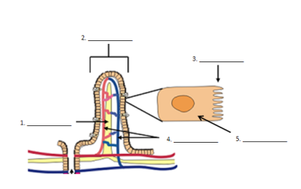

**Word bank**

Capillaries

Microvilli

Villus

Lacteal

Epithelial cell

1. Different methods of membrane transport are required to absorb different nutrients. Describe a specific example of a nutrient that uses each of the following methods:
   1. Simple diffusion
   2. Facilitated diffusion
   3. Active transport
   4. Exocytosis
2. Explain how starch is digested in the small intestines and then how its products are transported to the liver.
   1. What type of molecule is starch? Describe its structure.
   2. What enzymes break down starch? What are the products?
   3. How does glucose move from the lumen into the capillaries?
   4. How is glucose then transported to the liver? What happens to it there?