**Calculations in Microscopy**

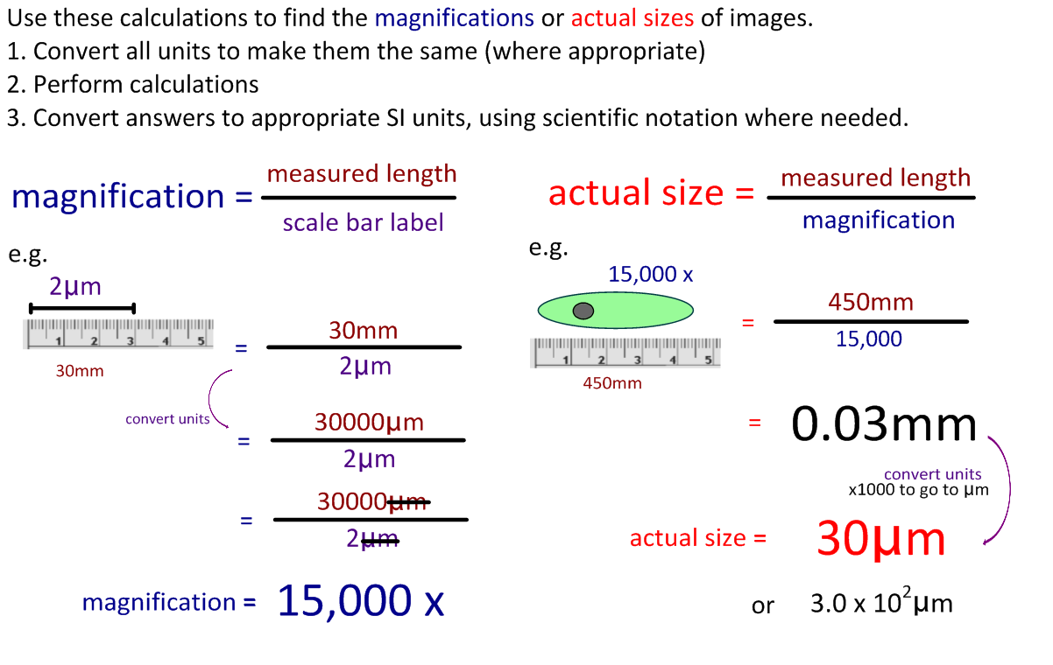

1. Calculate the magnification of these scale bars:

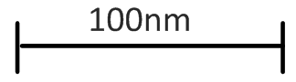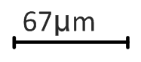

1. Calculate the actual size of these images:

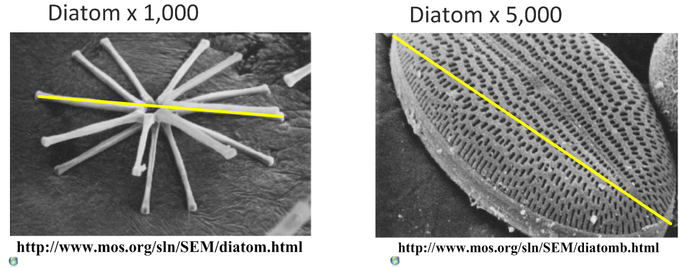

1. What would you need to do if you were only given a scale bar and asked to calculate actual size?

Demonstrate by finding the length of this stoma in µm. Show your working.

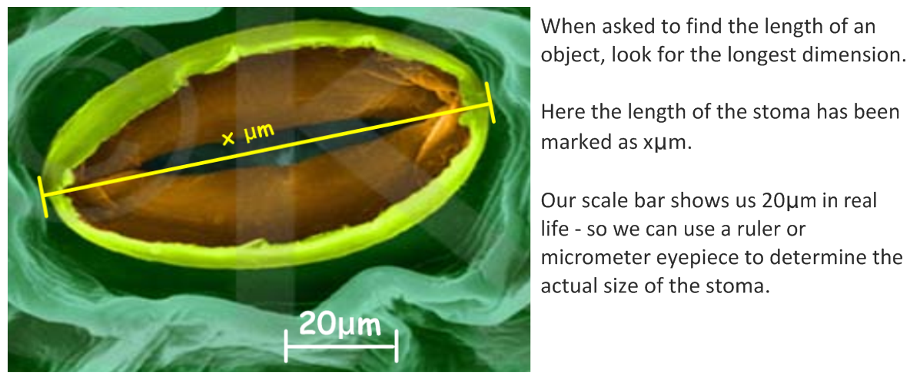

1. a. Calculate the length of this epithelial cell.

b. Calculate the diameter of the nucleus of this cell.

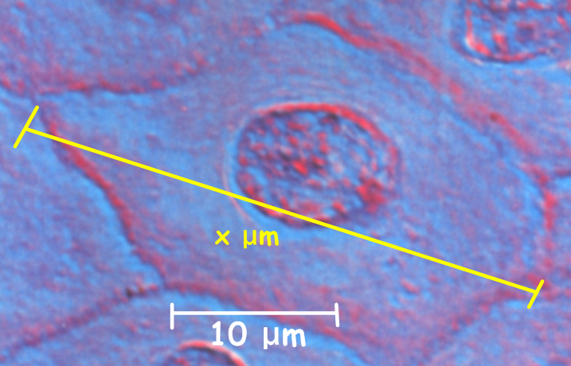

1. 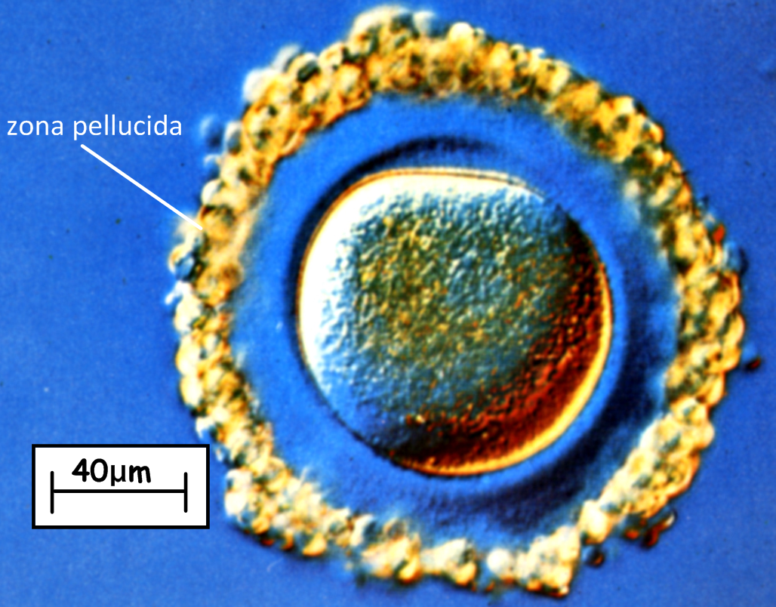a. Calculate the diameter of the main body of this human egg cell AND the thickness of one section of the zona pellucida.
2. Calculate the length of this *Elodea* cell.

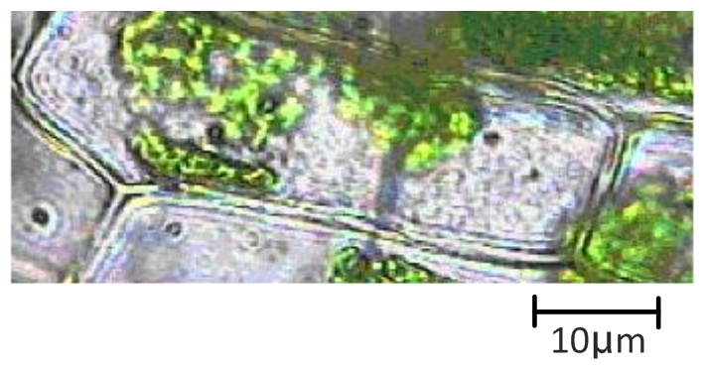

**Written questions:** (they might appear in this style in the exam)

1. A student views an image of a cell magnified 50,000 times. The image is 60mm long.
2. What is the actual length of the sample in the image?
3. Is the cell more likely to be a plant cell, animal cell, bacterium or virus? Explain why.
4. A sperm cell has a tail 50µm long. A student draws it 50mm long. What is the magnification?