**IB Theatre CAC**

**Assessment and Grading 2015/16**

**Year One**

IB Theatre students in their first year will explore the roles of performer, director, dramaturg, group ensemble, designer, production team and spectator. They will understand and experiment with Theatre in Context, Process and Presentation. Students will work on formative and summative assessments that mirror the Year internal and external IB Theatre assessments.

**Year Two**

IB students will complete External and Internal IB Theatre Assessments in their second year. HL and SL students will complete a Collaborative Project (IA), Research Presentation (ExA) and Director’s Notebook(ExA). At HL level they will need to complete a Solo Theatre Piece.

**CAC Grades will be assigned to mirror the year two assessments**

**SL Theatre Grading**

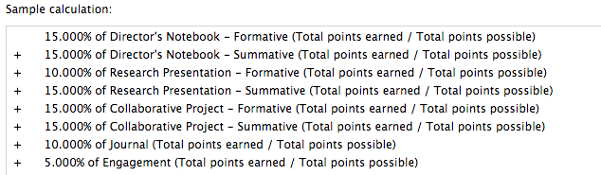

**HL Theatre Grading**

