**IB Biology: 6.2 The blood system - practice questions**

1. Label the parts of the heart below. Color areas with oxygenated blood red and deoxygenated blood blue. Draw arrows to show the pathway of blood.

[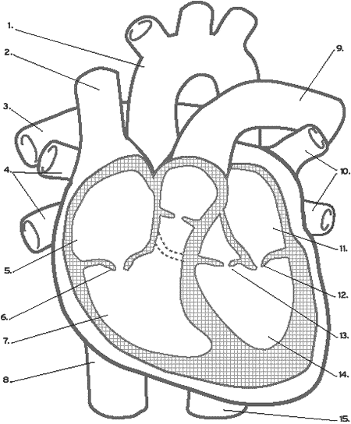](http://www.smm.org/heart/lessons/heartDiagram.html)

1. Which chambers of the heart have the thicker walls? [1mark]
2. Relate the thickness of the chambers to their functions. [2marks]
3. What is the function of the valves? [2 marks]
4. What is the type of muscle that makes up the walls of the heart? Why is it so special, and how does it maintain a constant blood supply? [3 marks]
5. Trace the pathway a drop of blood would take from the time it leaves the aorta, to the time it returns to the left ventricle ready to leave the aorta again, describing the chambers and vessels [4marks]

**Atrioventricular Valves:** Complete the following paragraph that describes what happens to bring about opening and closure of these valves:

Key words: atria, Atria, atria, blood, contract, open, Pockets, recoil, Rises, Ventricles

|  |  |
| --- | --- |
| **Opening Atrioventricular Valves:** | **Key Word** |
| 1. Ventricles relax and their walls |  |
| 1. Pressure in the ventricles drops below |  |
| 1. Atrioventricular valves |  |
| 1. Blood enters the heart and flows through the atria into the |  |
| 1. The pressure in the atria and ventricles slowly rises as they fill with |  |
| 1. The valves remain open while the atria |  |
|  | |
| **Closing Atrioventricular Valves:** |  |
| 1. Ventricles contract and the blood pressure in them |  |
| 1. The pressure in the ventricles rises above the pressure in the |  |
| 1. The blood pushes upwards and fills the valve |  |
| 1. This prevents the blood flowing back into the |  |

**Control of the cardiac cycle and key words:** Complete the following paragraph that describes what happens during the cardiac cycle.

Key words: Atrial, Atrial systole, AVN, Cardiac, Delayed (0.1 sec), Fibrillation, Interventricular septum, Myogenic, Out, Pacemaker, Purkyne, SAN

|  |  |
| --- | --- |
| **Phrase** | **Key word** |
| 1. The heart is made of this kind of muscle. |  |
| 1. Heart muscle can initiate its own contraction so it is referred to as this. |  |
| 1. Which group of muscles, the atria or ventricles tend to beat at a higher frequency? |  |
| 1. If the contraction of the heart is not synchronised, the heart will be in… |  |
| 1. The small patch of tissue in the right atrium that generates electrical activity. |  |
| 1. This patch of tissue sets the rhythm of the heart so it is sometimes referred to as the… |  |
| 1. When the atria contract, it is referred to as… |  |
| 1. The only route through down to the ventricles is via the.. |  |
| 1. At this point the signal is … |  |
| 1. The muscle tissue that separates the two ventricles |  |
| 1. The tissue that takes the excitation wave to the apex of the heart |  |
| 1. The heart contracts from the base to the top of the heart pushing the blood up and… |  |

Describe the cardiac cycle with reference to the action of the valves in the heart:

|  |  |  |
| --- | --- | --- |
| Correct |  | Mixed Up |
|  |  | Blood flows into atria from vena cava and pulmonary vein |
|  |  | Semi-lunar valves forced open and blood pushed out of heart |
|  |  | Atria and ventricles relax (diastole) |
|  |  | Atrioventricular valves snap shut as the flaps will with blood ‘lub’ |
|  |  | Atrial systole (atria contract at the same time) |
|  |  | Diastole returns |
|  |  | Internal volume of the heart increases as blood flows in |
|  |  | Blood falls back and fills flaps of semi-lunar valves |
|  |  | Semi lunar valves close ‘dub’ |
|  |  | Blood flows down into ventricles |
|  |  | Blood is pushed into the ventricles which stretch |
|  |  | Ventricular systole (ventricles contract) |

The graphs show some changes in pressure and volume during part of a cardiac cycle.



(a) Describe what the graphs show about the pressure and volume in the ventricle between times **X** and **Y**. (1)

.....................................................................................................................................

.....................................................................................................................................

(b) At point **Y,** the valve between the aorta and the ventricle opens. Use the information about pressure on the graph to explain why. (1)

.....................................................................................................................................

.....................................................................................................................................

(c) Explain the changes in the volume of the ventricle between times **X** and **Z**. (3)

.....................................................................................................................................

.....................................................................................................................................

.....................................................................................................................................

.....................................................................................................................................

Table 2 compares some features of different blood vessels from a dog.



(a) What is the thickness of one of the endothelial cells lining these blood vessels? (1)

Answer: ............................................................... µm

(b) Explain why an arteriole may be described as an organ. (2)

.....................................................................................................................................

.....................................................................................................................................

.....................................................................................................................................

(c) Use the information in **Table 2** to explain how the structure of the walls of arteries, arterioles and capillaries is related to their function. (6)

.....................................................................................................................................

.....................................................................................................................................

.....................................................................................................................................

.....................................................................................................................................

.....................................................................................................................................

.....................................................................................................................................

.....................................................................................................................................

.....................................................................................................................................

.....................................................................................................................................

.....................................................................................................................................

......................................................................................................................................