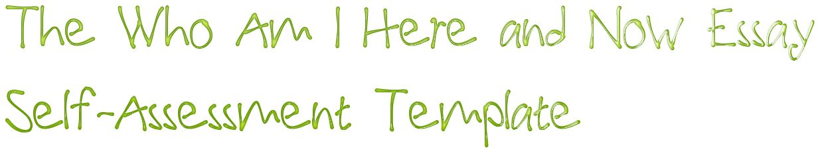

First, print a hard copy of your Who Am I Here and Now Essay. If you cannot find a copy, you can download a version from Turnitin.com. You will annotate your hard copy by following the instructions below. Then you will follow the instructions in both Parts A & B to mark this “Who Am I Here and Now Essay Self-Assessment Template.”

**A. Annotation**

1. For each category listed below, use the *italicized* instructions to annotate the hard copy of your Who Am I Here and Now Essay draft by hand.

2. Use the yellow highlighter function in your word processor to select the appropriate option in each category on this digital “Who Am I Here and Now Self-Assessment Template” that best describes your Who Am I Here and Now Essay draft.

3. Show both documents during class to your teacher for assessment.

**Manuscript Format:**

The draft is presented in full compliance with MLA ms format requirements. / The draft is not presented in full compliance with MLA ms format requirements.

**Scope/Plot:**

*Write “CONFLICT” in the left margin to indicate the moment where the central conflict is introduced. Write “CLIMAX” in the left margin to indicate the climax of your narrative.*

The draft presents a narrow plot that presents a clear conflict and its resolution. / The draft presents too broad a plot, lacks a clear conflict, or fails to resolve the conflict.

**Lead:**

*Place square brackets around the lead and describe its quality.*

The draft opens with an intriguing lead sentence crafted to compel the audience to want to read the next sentence. / The draft’s lead sentence is not compelling.

**Exposition = Setting + Characters:**

*Underline all the text that reveals time and place.*

The draft quickly establishes the specific time and place of the action. / The draft does not quickly establish the specific time and place of the action.

*Double underline all the text that describes characters. Write a “P” in the left margin to indicate imagery describing the protagonist.*

The draft deftly describes major characters, including the protagonist. / The draft describes some major characters, but not the protagonist. / The draft does not sufficiently describe major characters.

**Imagery:**

*Indicate imagery in the essay by using the symbols from the following key above all images. Use a “V” to denote visual images, “A” for auditory images, “O” for olfactory images, “G” for gustatory images, and “T” for tactile images.*

The draft provides rich multisensory descriptions of the settings and key characters. / The draft provides some multisensory descriptive details, but would benefit from additional imagery. / The draft provides insufficient multisensory imagery.

**Figurative Language:**

*Draw a box around all instances of figurative language and label the type of figurative language (simile, metaphor, personification, hyperbole, etc.).*

The draft uses figurative language sparingly and effectively. / The draft does not use figurative language effectively.

**Thesis:**

*If an explicit thesis is present, enclose it in square brackets and label it. If the essay does not include an explicit thesis, write the thesis immediately following the final paragraph.*

The narrative effectively implies a clear thesis. / The narrative concludes with an explicit thesis statement that is not a cliché. / The thesis of the essay is not clear.

**B. Reflection**

**Five Lessons I Must Remember When I Write My Next Personal Narrative**

Please use complete sentences in making these notes for your future self.

A.

B.

C.

D.

E.