[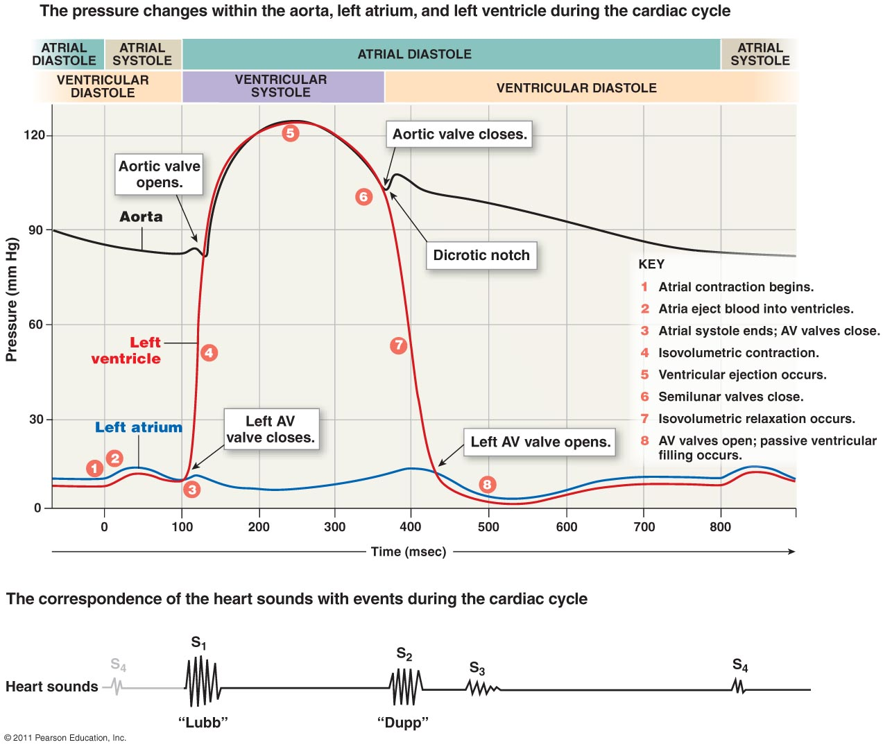](http://www.google.com/url?sa=i&rct=j&q=&esrc=s&source=images&cd=&cad=rja&uact=8&ved=0ahUKEwiczfTfse3KAhWMGj4KHZuDC3gQjRwIBw&url=http%3A%2F%2Fwww.highlands.edu%2Facademics%2Fdivisions%2Fscipe%2Fbiology%2Ffaculty%2Fharnden%2F2122%2Fnotes%2Fcvheart.htm&psig=AFQjCNEh3tvAYd98vH9T24GxBNBza7h1Kg&ust=1455200094444130)