Reader’s Guide for Adventures of Huckleberry Finn
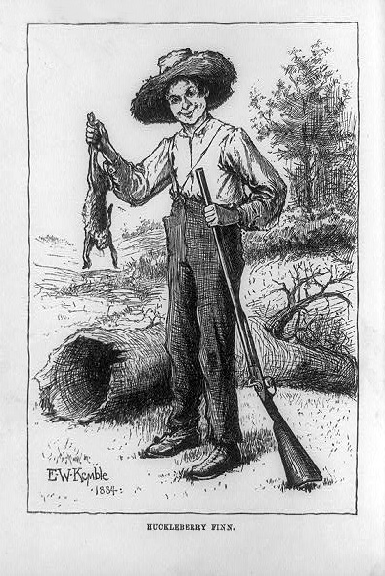
An 1884 illustration of Huckleberry Finn by Edward Windsor Kemble
From http://www.americaslibrary.gov/aa/twain/aa_twain_huckfinn_1_e.html

As you read Adventures of Huckleberry Finn for the first time, pay particular attention to the following motifs, events and ideas:

(Un)Reliability of the narrator(s)
What impact does the prefatory material play upon the main narrative? What problems in interpretation are created by Huck’s introduction of himself? Why do we keep referring to the narrator as if he’s a real person?

Problems of language
You may already know that the language employed by the novel has been problematic for many readers. What are the reasons for and effects of the frequent use of racist language? In addition, note shifts and tensions between concrete and abstract language. Also pay attention to different registers of language in the text, beginning with the claim about dialects in the “Explanatory.” What type of irony is introduced by that claim? Note the language employed by Huck and Jim and its effects: what is revealed about their characters? Also consider shifts in diction, including failures and their effects, in the language employed by other characters, including the Duke and King. What do characters reveal via the way they speak?

The picaresque
M.H. Abrams points out that “picaresque fiction is realistic in manner, episodic in structure (that is, composed of a sequence of events held together largely because they happened to one person), and often satiric in aim.” What elements of the novel reveal it as an example of the picaresque? What are the effects of these elements?

Elements of satire
“Satire,” according to M.H. Abrams, “is the literary art of diminishing or derogating a subject by making it ridiculous and evoking toward it attitudes of amusement, contempt, scorn or indignation.” Satire is distinct from comedy because satire “uses laughter as a weapon, and against a butt that exists outside the work itself.” What facets of American life or elements of human nature serve as the butts of satire in the novel? In what ways does the novel elicit “amusement, contempt, scorn or indignation” towards these targets?

Huck’s (moral) development
M.H. Abrams reveals that the bildungsroman, or “novel of formation,” offers as its subject “the development of the protagonist’s mind and character, in the passage from childhood through varied experiences—and often through a spiritual crisis—into maturity, which usually involves recognition of one’s identity and role in the world.” Does the novel reveal Huck as a dynamic character? If so, how does he change? What is Huck’s attitude toward “civilization” and authority? Which institutions are trying to civilize him? Is Huck’s primary growth external or a movement inward toward self-understanding and acceptance? Consider Huck’s movement toward nature: what sort of growth, if any, is revealed?
Pay particular attention to episodes that seem to enlighten Huck to his own moral center, including his apology to Jim at the end of Chapter XV, the Duke and King’s various schemes, Huck’s reaction to their punishment at the end of Chapter XXXIV, and Huck’s ultimate rejection of Tom Sawyer’s Romanticism. Note any moral crises Huck encounters.

The supernatural and religion
Track moments in which characters discuss superstitions and religious beliefs. What aspects of character and worldview are revealed in these moments? Where does Huck appear to be religious? Note carefully moments when Huck contemplates the ideas of God and an afterlife or attempts to pray. Pay special attention when Huck considers that, according to his society, helping a slave escape will condemn him to Hell. Many critics read Huck’s dramatic declaration, “All right, then, I’ll GO to hell,” as a direct attack by Twain on the religious support of slavery in the U.S.. Throughout the novel, Huck continually questions his own motivation and life in general. Collect examples and comment upon them.

Echoes of Emerson
Remember this passage from “The American Scholar”:
Books are for the scholar’s idle times. When we can read God directly, the hour is too precious to be wasted in other men’s transcripts of their readings. But when the intervals of darkness come, as come they must, — when the sun is hid, and the stars withdraw their shining, — we repair to the lamps which were kindled by their ray, to guide our steps to the East again, where the dawn is.
Note instances in which Huck rejects books, longs for nature, prefers sleeping outdoors, loathes new clothes or any clothes at all, and reveals his comfort with animals. Is Huck a hyperbolic personification of Emersonian ideals?

Slavery
The Civil War had ended some twenty years before the novel was published. Because the novel offers a realist depiction of slave times, including slaveholders’ attitudes toward slaves and race language common in the period, the novel and its author have sometimes been labeled as racist. Yet part of Huck’s moral development can be perceived as the correction or removal of racist attitudes. Track Huck’s perceptions of slavery and slaves, especially Jim, throughout the novel. Consider carefully Huck’s gradual acceptance of Jim as a man, strong, brave, generous, and wise, but also note that Jim is realistically portrayed as imperfect.

Family, Social Status and Identity
Collect references to types of families and social classes and consider the effects of both upon their members.

Life on the Mississippi
Life on the Mississippi River is alternately idyllic and threatening. It’s a real river, of course, but it’s also a symbol, a very complex symbol. Note, for example, the direction in which it flows. Consider carefully each description of the Mississippi. Much of the boyhood innocence and romantic depictions of nature occur in the first sixteen chapters and the last five, while the middle chapters reveal the harsh realities of antebellum society. Note transitions from one to the other.

The attack on Romanticism
Pay close attention to the King and Duke’s appeals to those they swindle and to the feud between the Grangerfords and the Shepherdsons. What about a sunken steamboat called Walter Scott? What do you make of the poem, “Ode to Stephen Dowling Bots,” by Emmeline Grangerford? Consider the description of the Grangerford parlor and Emmeline Grangerford’s paintings. What about the contrast between Huck and Tom? How does Tom’s return at the end of the novel reveal changes that Huck has undergone? Compare Jim’s escape from imprisonment, guided by Tom’s reading in Romances, with Huck’s earlier escape from imprisonment by his father in the cabin on the island, guided by his own common sense. Is a sort of literary criticism implied by the novel?

The ending
What is the effect of the long sequence at Phelps Farm? Consider the return of Tom: some critics hold that the beginning and ending of the book, the parts in which Tom Sawyer appears, detract from its overall impact. Others feel Tom serves to start the story off and to bring it to a conclusion, and that Tom’s ridiculous schemes have the paradoxical effect of providing a framework of “reality” around the myth-like river voyage. Has Huck learned anything if he falls so easily under Tom’s influence when Tom returns? Is there a circular nature to the plot: in other words, how is the end of the novel like the beginning? What is different? Some critics maintain that the ending of the novel is more unified than in most picaresque narratives. If we agree that there are three lines of action—Huck’s escape from civilization, the conflict between Huck and Pap, and Jim’s escape from slavery—does the end of the novel resolve these three plot arcs? What are the implications of Huck’s final declaration?

