IB Biology HL: 6.3: Defence against infectious disease

The skin and mucous membranes form a primary defence against pathogens that cause infectious disease.

A pathogen is a disease-causing micro-organism, virus or prion.
[According to the CDC, prions are abnormal, pathogenic agents that are transmissible and are able to induce abnormal folding of specific normal cellular proteins called prion proteins that are found most abundantly in the brain. The functions of these normal prion proteins are still not completely understood. The abnormal folding of the prion proteins leads to brain damage and the characteristic signs and symptoms of the disease. Prion diseases are usually rapidly progressive and always fatal.]
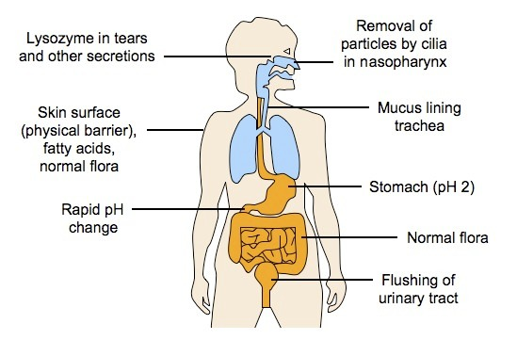
The first line of defense against infection
are the surface barriers that prevent
entry of pathogens

Skin
- Protects external structures
(outer body areas)
- A dry, thick and tough region
made of predominantly dead
surface cells
- Contains biochemical defense
agents (sebaceous glands which
secrete chemicals inhibiting the
growth of some bacteria)
- Releases acidic secretions to lower
pH and prevent bacteria from growing

Mucous membranes
- Protect internal structures (externally accessible cavities and tubes, such as trachea, vagina and urethra)
- A thin region containing living surface cells that release fluids to wash away pathogens (mucus, tears, saliva, etc.)
- Contains biochemical defense agents (secretions contain lysozyme, which can destroy cell walls and cause cell lysis)
- Mucous membranes may be ciliated to aid in the removal of pathogens (along with physical actions such as coughing or sneezing)

Cuts in the skin are sealed by blood clotting. Clotting factors are released from platelets. The cascade results in the rapid conversion of fibrinogen to fibrin by thrombin.
- Clotting (hemostasis) is a mechanism that prevents the loss of blood from broken vessels
- Damaged cells and platelets release chemical signals called clotting factors which trigger a coagulation cascade:
  - Clotting factors convert the inactive zymogen, prothrombin, into the activated enzyme thrombin (a zymogen is an inactive precursor that is converted into an active enzyme by action of an acid or another enzyme or by other means; a proenzyme)
  - Thrombin catalyzes the conversion of the soluble plasma protein fibrinogen into an insoluble form (fibrin)
  - Fibrin forms an insoluble mesh of fibers that trap blood cells at the site of damage
- Clotting factors also cause platelets to become sticky, which then adhere to the damaged region to form a solid plug called a clot
- The clot prevents further blood loss and blocks entry to foreign pathogens
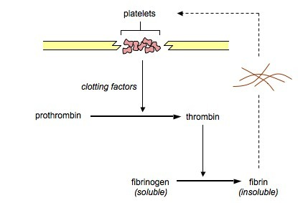

Causes and consequences of blood clot formation in coronary arteries.
- Coronary arteries branch off of the aorta close to the semilunar valve
- Carry blood to the wall of the heart (oxygen and glucose are needed for cellular respiration in heart muscle cells)
- Coronary thrombosis is the formation of blood clots in the coronary arteries
- Deprives part of the heart of oxygen and nutrients - cardiac muscle cells cannot provide sufficient ATP
- Wall of heart makes quivering movements called fibrillation that do not pump blood effectively
- Can be fatal
- Risk of cardiac thrombosis increases in people with atherosclerosis (coronary occlusion). Atheromas can also cause damage to artery endothelium, hardening of artery walls due to calcium salt deposits, or rupture, causing lesions.
- Risk factors for coronary thrombosis and heart attacks: smoking, high blood cholesterol concentration, high blood pressure, diabetes, obesity, lack of exercise.

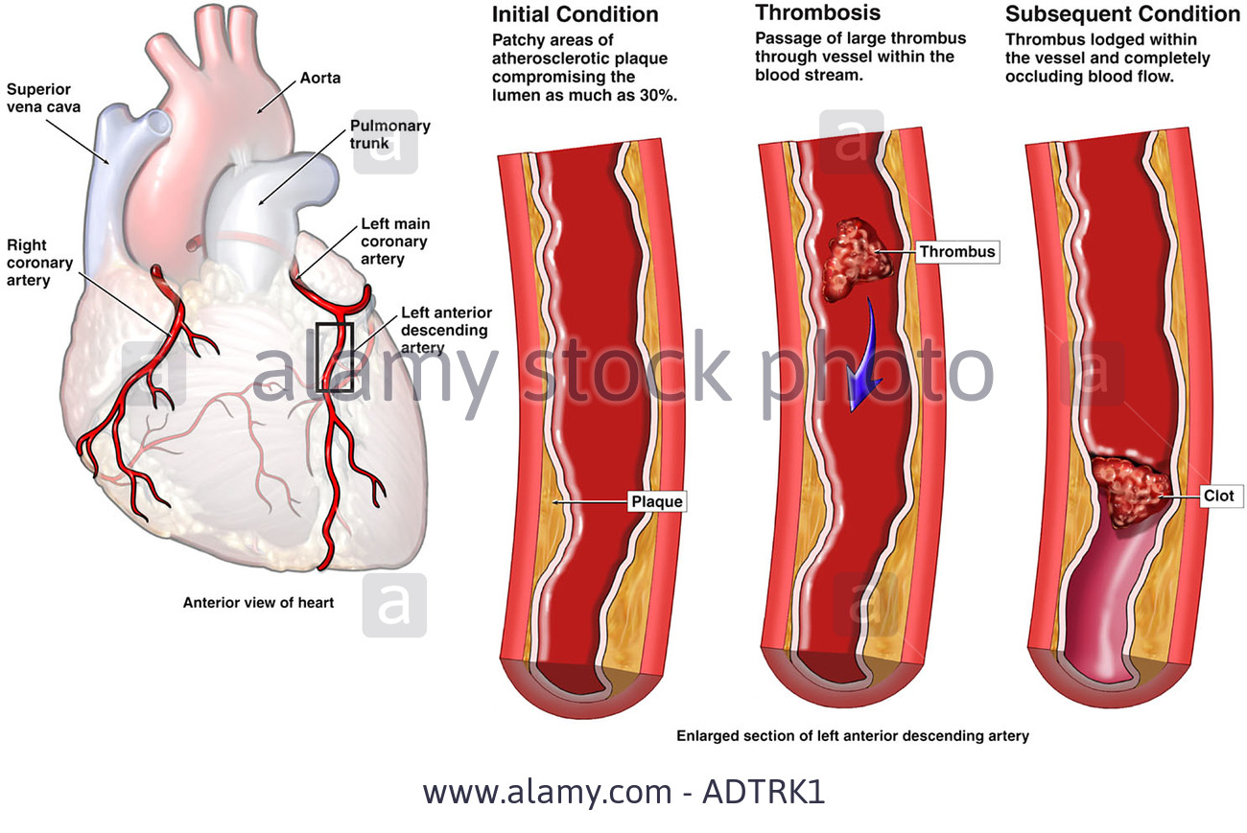
Ingestion of pathogens by phagocytic white blood cells gives non-specific immunity to diseases.

The second line of defense against pathogens are non-specific defense mechanisms which do not differentiate between types of microorganisms and always invoke the same response
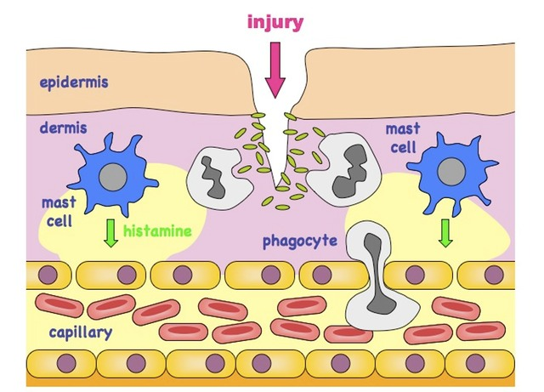
Examples include phagocytic leucocytes, inflammation, fever and anti-microbial proteins

- Phagocytic leucocytes (macrophages)
circulate in the blood but may move into body
tissue (extravasation) in response to infection.
- They concentrate at sites of infection due to
the release of chemicals (such as histamine)
from damaged body cells

- Pathogens are engulfed when pseudopods
surround pathogen and fuse, enclosing it in a
vesicle. This mechanism of endocytosis is
called phagocytosis. The vesicle may fuse
with a lysosome to digest the pathogen
- Some of the pathogens antigenic fragments
may be presented on the surface of the
macrophage, in order to help stimulate
antibody production

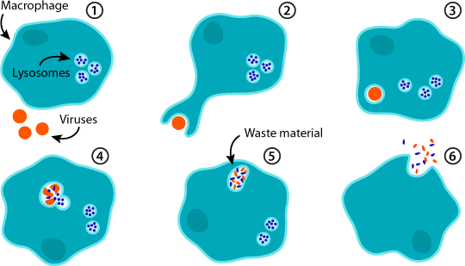

Production of antibodies by lymphocytes in response to particular pathogens gives specific immunity.
The third line of defense are specific defenses, coordinated by a type of leucocyte called lymphocytes
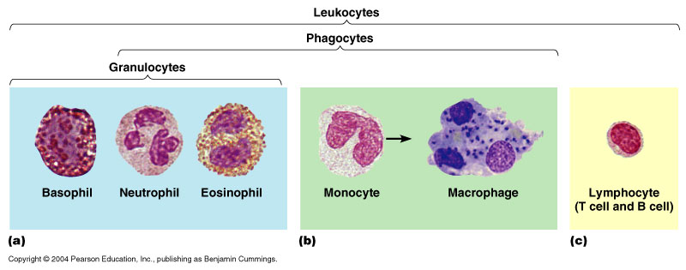
Lymphocytes recognize and respond specifically to different types of micro-organism and have memory (can respond more effectively upon reinfection)
Antigen: A substance that the body recognizes as foreign and evokes an immune response. “Self” markers are located on cell membranes of every cell within an organism and are proteins called MHC markers (major histocompatibility markers).
Antibody: A protein produced by certain white blood cells (B lymphocytes, plasma cells) in response to an antigen
- Antibodies are made up of 4 polypeptide chains (2 light and 2 heavy chains) joined together by disulphide bonds to form a Y-shaped molecule
- The ends of the arms bind the antigens, called the variable regions, these will differ between antibodies
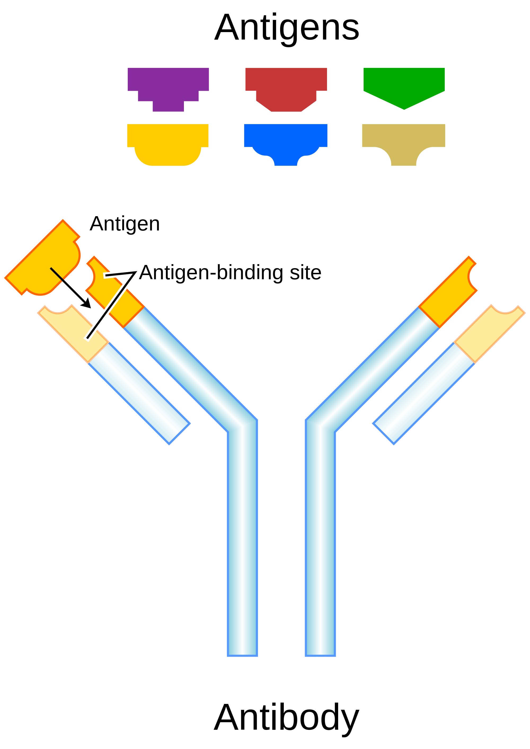
- Each type of antibody recognize a unique antigenic fragment, very specific (like enzyme-substrate interactions)

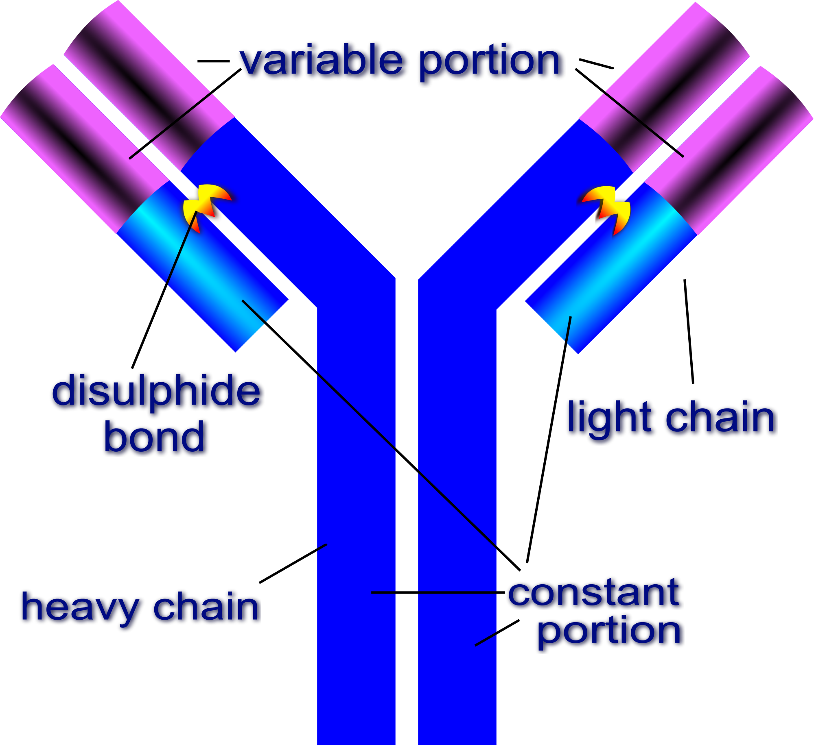

Antibody production:
- B lymphocytes (B cells) are antibody-producing cells that develop in the bone marrow to produce a highly specific antibody that recognizes one type of antigen
- When antigens enter the body, they are engulfed and destroyed by macrophages but not completely – the antigen becomes attached to the MHC marker to form an MHC-antigen complex, which is then displayed on the macrophage’s surface. Macrophage is known as an antigen-presenting cell and is noticed by helper-T lymphocytes (T_{H} cells)

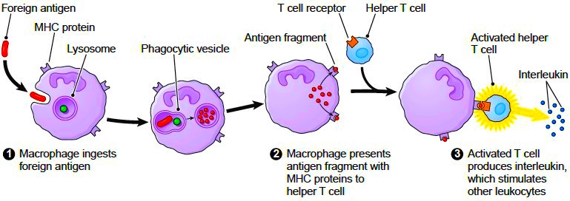

- These cells activate the appropriate B cell which divides and differentiates into short-lived plasma cells that produce massive quantities of antibody (~2,000 molecules per second for ~4 to 5 days)
- A small proportion of B cell clones develop into memory cells, which may survive for years providing long-term immunity

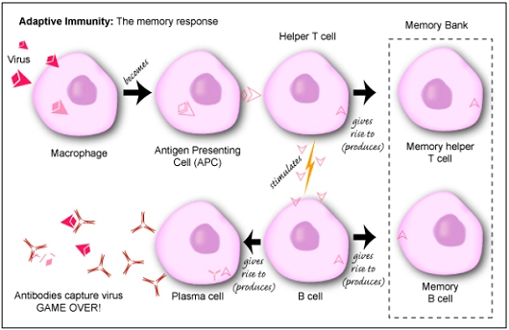

Antibiotics block processes that occur in prokaryotic cells but not in eukaryotic cells. Viral diseases cannot be treated using antibiotics because they lack a metabolism.
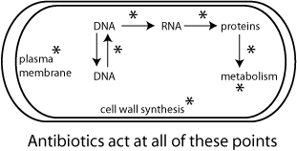
Antibiotics are substances that kill or inhibit bacterial growth by targeting different metabolic pathways of prokaryotes
Specific prokaryotic features targeted include key enzymes, 70S ribosomes and the bacterial cell wall
Because eukaryotic cells do not have these features, antibiotics kill bacterial cells without harming humans (or viruses)
Virus do not carry out metabolic reactions themselves but instead infect host cells and take over their cellular machinery
Viruses need to be treated with specific antiviral agents that target features specific to viruses (e.g. reverse transcriptase in retroviruses)
Some strains of bacteria have evolved with genes which confer resistance to antibiotics and some strains of bacteria have multiple resistance.
Review of 5.2 Evolution:
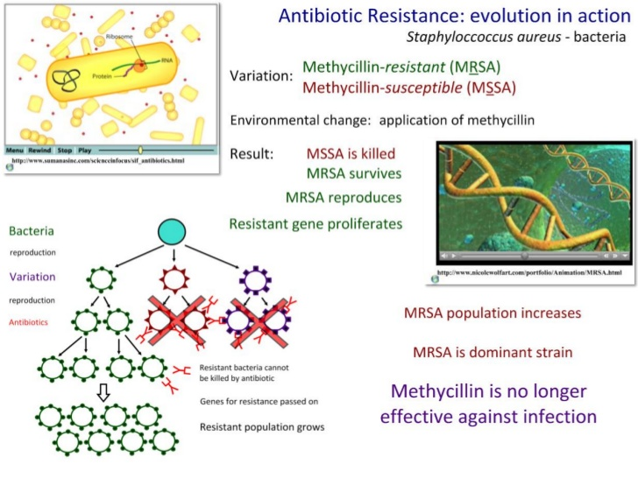
To avoid antibiotic resistance:
- doctors prescribe antibiotics for serious infections only
- patients complete entire course of antibiotics to be sure infections is eliminated
- hospital staff maintain high standards of hygiene to prevent cross-contamination
- farmers avoid using antibiotics in animal feeds
- pharmaceutical companies need to develop new types of antibiotic

Florey and Chain's experiments to test penicillin on bacterial infections in mice. Risks associated with scientific research: Florey and Chain's tests on the safety of penicillin would not be compliant with current protocols on testing.
Ernst Chain, along with another chemist, Edward Penley Abraham, worked out a successful technique for purifying and concentrating penicillin... In March 1940 Chain ran down to a laboratory that maintained test animals and requested that two mice be injected with a sample of the penicillin that he and Abraham had extracted. Though the injection represented a far higher dosage than that administered in Fleming’s similar experiment, the mice survived apparently unharmed; the more-concentrated penicillin had passed its first toxicity test. Howard Florey then directed that the antibacterial properties of penicillin in mice be tested—the crucial step that Fleming had not taken. On May 25 eight mice were injected with hemolytic streptococci (which among other diseases causes puerperal fever in new mothers), and four of these were subsequently injected with measured and timed doses of penicillin. Sixteen and a half hours later the four mice that had received penicillin were alive, but their untreated fellows were dead—a finding that caused great excitement among the researchers. Further testing involving hundreds of mice was carried out through the summer. On August 24, 1940, Florey and Chain reported their findings in the Lancet; the article electrified research groups around the world that were seeking cures for bacterial disease. By then World War II had already engulfed Europe, and the military importance of a more successful means of combating the diseases and infections that had decimated armies of the past was immediately recognized.
In early January 1941 Florey was ready to test penicillin on humans. The first English patient to whom the drug was administered was a young woman whose cancer was beyond treatment and who had agreed to test penicillin’s toxicity. She showed an alarming reaction—trembling and sharply rising fever. However, Abraham was able to show that impurities in the drug, not the drug itself, had caused the adverse reaction. In February a policeman became the first patient with an infection to be treated with penicillin in the hope of achieving a cure. No one knew the dosages and the length of treatment required to eliminate various bacterial infections; these parameters were being worked out by just such trials—primitive by today’s standards. The policeman’s condition at first improved with the penicillin therapy and then relapsed. The penicillin supply had almost run out, and even retrieving penicillin from the man’s own urine (a commonly used procedure in the early clinical trials) failed to save him. Florey vowed that from then on he would always have enough penicillin to complete a treatment.
Excerpt from: http://www.chemheritage.org/discover/online-resources/chemistry-in-history/themes/pharmaceuticals/preventing-and-treating-infectious-diseases/florey-and-chain.aspx
Effects of HIV on the immune system and methods of transmission.
- The human immunodeficiency virus (HIV) is a retrovirus that infects helper T lymphocytes (T_{H} cells)
- Reverse transcriptase allows viral DNA to be produced from its RNA code, which is integrated into the host cell’s genome
- After a number of years of inactivity (during which infected T_{H} cells have continually reproduced), the virus becomes active and begins to spread, destroying the T_{H} cells in the process (known as the lysogenic cycle)
- This results in lower immunity as antibody production is compromised - the individual is now susceptible to opportunistic infections

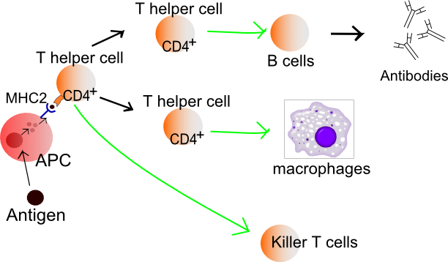
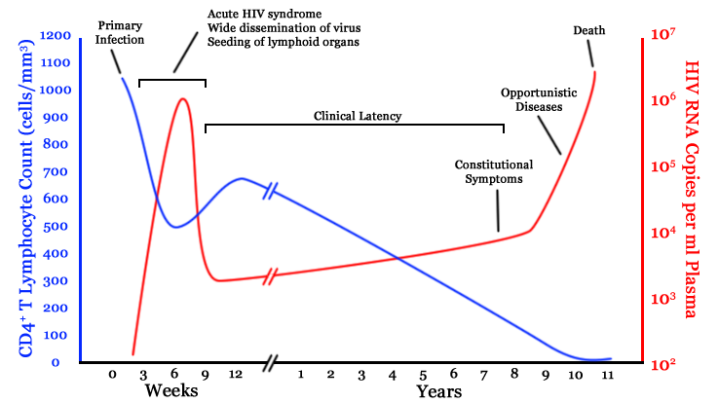
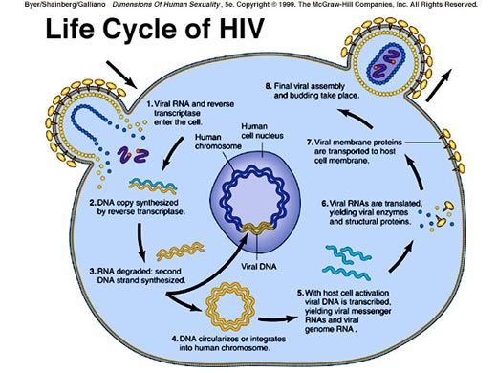
Transmission of HIV
- HIV is transmitted through the exchange of bodily fluids (including unprotected sex, blood transfusions, breast feeding, child birth, etc.)
- The risk of exposure to HIV through sexual contact can be reduced by using condoms
- A minority of people are immune to HIV infection (they do not have the CD4+ T cell receptor that HIV needs to infect the cell)

Cause of AIDS
- Acquired Immunodeficieny Syndrome (AIDS) is a collection of symptoms and infections caused by the destruction of the immune system by HIV
- While HIV infection results in a lowering in immunity over a number of years, AIDS describes the final stages when observable symptoms develop

