IB Biology HL: 6.2 The blood system

Arteries convey blood at high pressure from the ventricles to the tissues of the body. Arteries have muscle and elastic fibers in their walls. The muscle and elastic fibers assist in maintaining blood pressure between pump cycles.

- Arteries carry blood at high pressure (80-120 mm Hg) from the ventricles, which are thick and muscular
- They have a narrower lumen (to maintain high pressure) surround by a thick wall made of two layers
- The middle layer (tunica media) contains muscle and elastin to help maintain pulse flow (it can contract and stretch)
- The outer layer (tunica adventitia or tunica externa) contains collagen prevents the artery rupturing due to the high pressure blood flow
- Valves at the exit of the heart prevent backflow into the heart
- High blood pressure that enters arteries is the systolic pressure – it pushes wall of artery outward, widens the lumen and stretches the elastic fibers in the wall (stores potential energy)
- At the end of the heartbeat, blood pressure in arteries falls – stretched elastic fibers squeeze blood in the lumen. This minimum pressure is the diastolic pressure.
- Blood flows through arteries in pulses, which can be felt in shallow arteries in the wrist and neck.
- Blood pressure can be measured with a blood pressure monitor. It is reported as the systolic pressure/diastolic pressure. Normal adult systolic pressure should be 90-119 mm Hg and diastolic pressure should be 60-79 mm Hg.
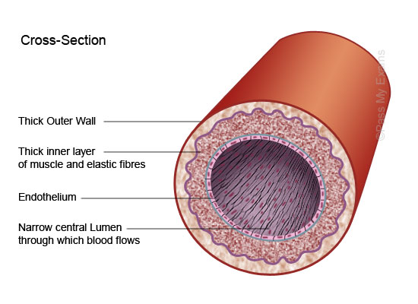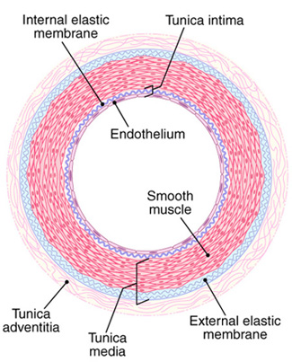

Blood flows through tissues in capillaries with permeable walls that allow exchange of materials between cells in the tissue and the blood in the capillary.
- Capillaries are involved with material and gas exchange with the surrounding body tissue
- Blood pressure in the capillaries is relatively low (~15 mm Hg) and they have a very small diameter (~5 micrometers wide)
- Their wall is NOT made up of muscle, but is made up of a single layer of cells to allow for ease of diffusion
- Capillaries may contain pores to aid the transport of material but no valves
- Capillaries connect arteries and veins and contact almost all body tissues
- Permeability of capillary walls differs between tissues and can change over time
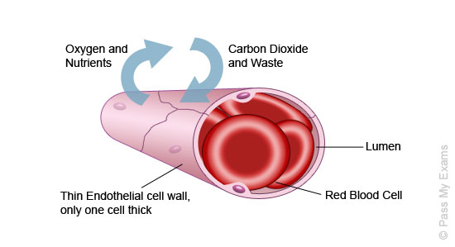
Capillaries:
Veins collect blood at low pressure from the tissues of the body and return it to the atria of the heart. Valves in veins and the heart ensure circulation of blood by preventing backflow.
- Veins carry blood under low pressure (<10 mm Hg) from the capillaries to the heart
- They have a very wide lumen (keeps pressure low and allows greater flow of blood)
- The walls of tissue surrounding the vein are thin and less elastic than arteries (blood is not travelling in rhythmic pulses)
- They have valves to prevent blood pooling at extremities (arteries do not have valves)
- Valves are pocket valves (three flaps of tissue) – blood that starts to flow backward gets caught in the flaps of the valve which block the lumen of the vein
- Blood flow in veins is assisted by gravity and pressures exerted on them by other tissues (exercise improves venous blood flow because skeletal muscle contraction pushes on veins)
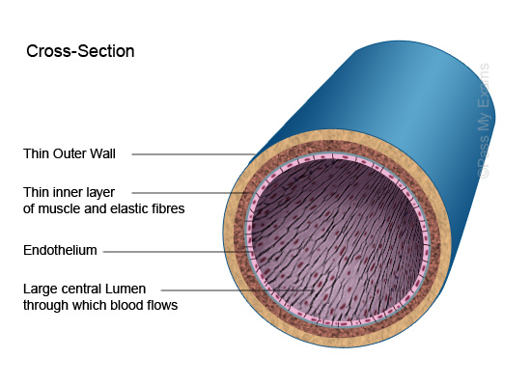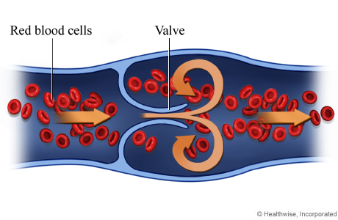
Identification of blood vessels as arteries, capillaries or veins from the structure of their walls.
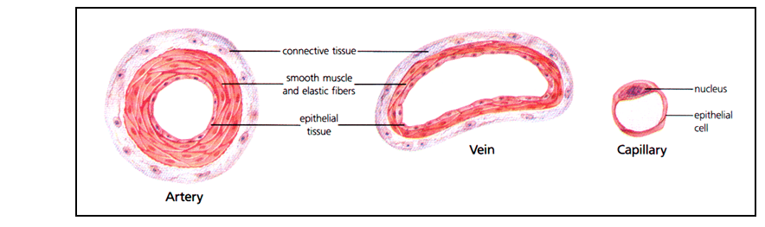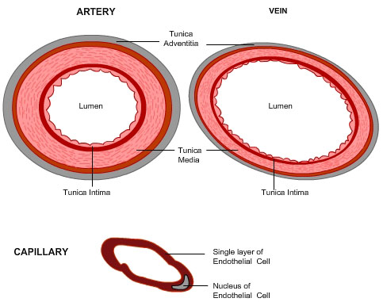
William Harvey's discovery of the circulation of the blood with the heart acting as the pump. Theories are regarded as uncertain: William Harvey overturned theories developed by the ancient Greek philosopher Galen on movement of blood in the body.
William Harvey (1578-1657), the father of modern physiology, was the first researcher to discover the circulation of blood through the body. Although we take this knowledge for granted, until Harvey's time, people were not aware that the blood travels through the body and is pumped through its course by the heart.
Harvey's great contribution to medicine was his revolutionary discovery of the circulation of blood. By dissecting both living and dead animals, Harvey became convinced that the ancient Greek anatomist Galen's ideas about blood movement must be wrong, particularly the ideas that blood was formed in the liver and absorbed by the body, and that blood flowed through the septum (dividing wall) of the heart. Harvey first studied the heartbeat, establishing the existence of the pulmonary (heart-lung-heart) circulation process and noting the one-way flow of blood. When he also realized how much blood was pumped by the heart, he realized there must be a constant amount of blood flowing through the arteries and returning through the veins of the heart, a continuing circular flow.
Harvey published this radical new concept of blood circulation in 1628. It provoked immediate controversy and hostility from the medical community of the time, contradicting as it did the usually unquestioned teachings of Galen. The most virulent critic, Jean Riolan, scorned Harvey as a "circulator," an insulting term for a traveling quack. Harvey calmly and quietly defended his work, and although his medical practice suffered for a time, his ideas become widely accepted by the time of his death. The discovery of capillaries by Marcello Malpighi in 1661 provided factual evidence to confirm Harvey's theory of blood circulation.
Excerpted from: http://www.discoveriesinmedicine.com/General-Information-and-Biographies/Harvey-William.html#ixzz3zFVXaZ7u

Recognition of the chambers and valves of the heart and the blood vessels connected to it in dissected hearts or in diagrams of heart structure. There is a separate circulation for the lungs.
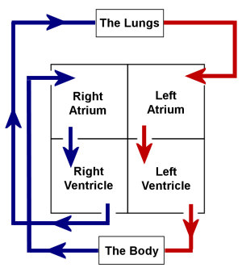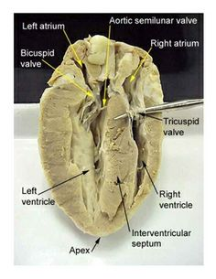

Humans have two separate circulations:
- Pulmonary circulation: to and from the lungs – receives deoxygenated blood that has returned from systemic circulation
- Systemic circulation: to and from all other organs, including the heart muscles – receives oxygenated blood from pulmonary circulation
- Critical that blood flowing from these two circulations is not mixed
- Heart serves as a double pump, delivering blood under different pressures separately to the two circulations

Virtual Heart Dissections:
http://www.biologycorner.com/anatomy/circulatory/heart/heart_dissection.html
http://anatomycorner.com/main/image-gallery/sheep-heart/
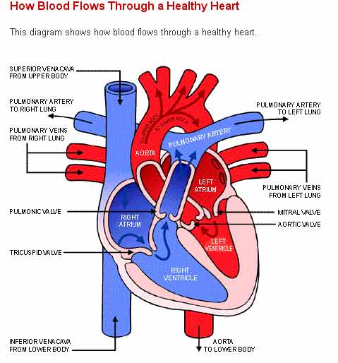

The action of the heart in terms of collecting blood, pumping blood and opening and closing valves:
- Blood returning from all parts of the body (except lungs) enter the right atrium via the vena cava - this blood is relatively deoxygenated (shown as blue)
- The blood passes from the right atrium to the right ventricle and then via the pulmonary artery to the lungs (where blood is reoxygenated – shown as red)
- The blood returns to the left atrium via the pulmonary vein and passes through the left ventricle to the aorta, where it is pumped around the body
- Contraction pushes blood into the ventricles. Atrio-ventricular (mitral and tricuspid) valves and semilunar (pulmonary and aortic) valves prevent backflow of blood. Blood flows one way only! Ventricles have thicker muscle as they push blood into the arteries: higher pressure and further distance.
- Flow of blood is double circulation: each full pass through the body must pass through the heart TWICE.

The heart valves maintain the one-way flow of blood:
- When the atria contract, atrioventricular (AV) valves open
- Blood flows from the atria and into the ventricles
- When the ventricles contract, the AV valves close and semilunar valves open
- This forces blood out of the ventricles and into the arteries
- As arterial pressure rises, the semilunar valves close, ensuring the one-way flow of blood

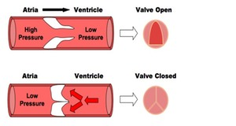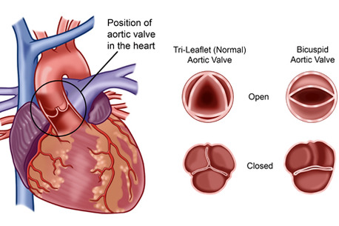
Causes and consequences of occlusion of the coronary arteries.
- Coronary arteries supply heart muscle with oxygen and nutrients
- The heart is a muscle that must continually contract in order to pump blood around the body
- Coronary arteries form a network of vessels around the heart and supply the cardiac tissue with oxygen and nutrients (i.e. glucose)
- These are required to produce the necessary energy via aerobic respiration - if a coronary artery is blocked, a heart attack may occur
- Atherosclerosis: fatty tissue (atheroma) build up in artery wall next to endothelium – artery wall bulges into the lumen narrowing it and impeding blood flow
- Atherosclerosis often is unnoticed until a major artery is blocked
- Risk factors for atherosclerosis: high LDL concentrations in blood, high chronic blood glucose concentrations, chronic high blood pressure, consumption of trans fats, infection with Chlamydia pneumoniae, production of TMAO by intestinal microbes

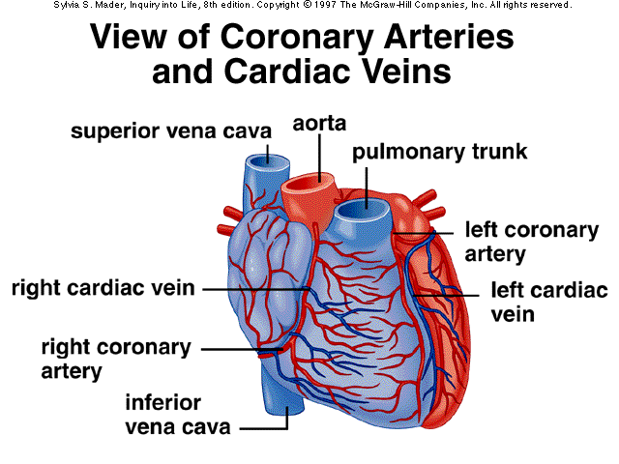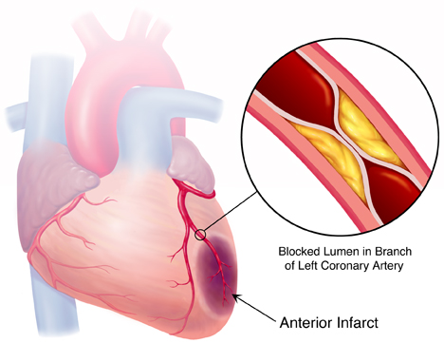
Pressure changes in the left atrium, left ventricle and aorta during the cardiac cycle.

The Cardiac Cycle
The heart muscle contracts rhythmically with a period of rest between each contraction. The contraction period is called the systole, and the relaxation period is called the diastole:
Atrial systole
The atria contract and force blood into the ventricles. The contraction occurs around the openings of the veins into the atria first so that these are closed up to prevent back flow into them.
Ventricular systole
The ventricles contract and force the blood under pressure, past the semi lunar valves into the arteries. The closing of the bicuspid and tricuspid valves prevents back flow. At the same time the atria and ventricles relax and blood begins to flow back into them from the veins.
Diastole
The muscles of both atria and ventricles relax. The heart fills with blood, which is prevented from flowing straight out again by closing the seminar valves in the arteries.

Pressure Changes during the Cardiac Cycle
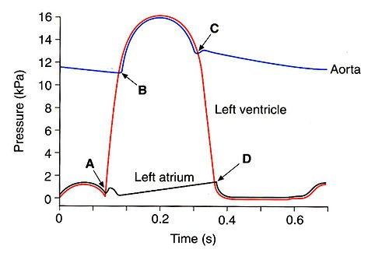
Starting at the leftmost side:

Left Atrium
Pressure rises due to atrial contraction (atrial systole) then drops as blood flows into the ventricle. Mitral valve then closes due to pressure in the ventricle rising above that in the atrium (first heart sound, A). Pressure in the atrium steadily rises as blood is returned to the atrium during systole, when the mitral valve is closed. The mitral valve then opens (D) and the pressure drops as blood flows under gravity straight through the atrium into the ventricle.

Left Ventricle
Pressure rises as blood is forced from the atria into the ventricle. The ventricle then contracts (ventricular systole), causing the mitral valve to close (A). Pressure rises sharply in line with ventricular contraction until the intraventricular pressure is greater than the pressure in the aorta (afterload), at which point the aortic valve opens (B) and blood is forced into the aorta. The lack of blood in the ventricle causes pressure to drop, until it drops below aortic pressure and the aortic valve closes due to backflow pressure in the aorta (second heart sound, C). Both the valves are now closed, and the ventricular pressure continues to drop as the myocardium relaxes (diastole), when the pressure drops below the left atrial pressure the mitral valve opens (D), blood flows into the ventricles under gravity, causing gradual pressure rise

Aorta
Blood pressure gradually drops following the previous heartbeat, until diastolic pressure is reached (B), at which point the aortic valve opens and blood from the contracting left ventricle is forced into the aorta, rapidly reaching the diastolic BP. The BP then drops as the myocardium begins to relax and backflow pressure on the aortic valve causes it to close (C). When the aortic valve closes, the arterial walls recoil (elastic recoil), causing the brief pressure rise, the dicrotic notch.
Excerpt from: http://www.thestudentroom.co.uk/wiki/Revision:The_heart_beat
The heartbeat is initiated by a group of specialized muscle cells in the right atrium called the sinoatrial node. The sinoatrial node acts as a pacemaker. The sinoatrial node sends out an electrical signal that stimulates contraction as it is propagated through the walls of the atria and then the walls of the ventricles. The heart rate can be increased or decreased by impulses brought to the heart through two nerves from the medulla of the brain. Epinephrine increases the heart rate to prepare for vigorous physical activity.
- The contraction of the heart tissue (myocardium) is myogenic, meaning the signal for cardiac contraction arises within the heart muscle cells, called myocytes (not controlled externally)
- Within the wall of the right atrium are a specialized plexus of nerves called the sinoatrial node (SAN)
- The sinoatrial node (pacemaker) initiates contraction of the cardiac muscle and acts as a pacemaker, regulating normal sinus rhythm
- It stimulates atria to contract and, when excitation reaches the junction between atria and ventricles, stimulates another node (atrioventicular node)
- The atrioventricular node (AVN) sends signals via the Bundle of His to Purkinje Fibers, which cause ventricular contraction
- This sequence always ensures there is a delay between atrial and ventricular contractions, resulting in two heart sounds ('lub dub')

Myogenic Control of the Heart Beat
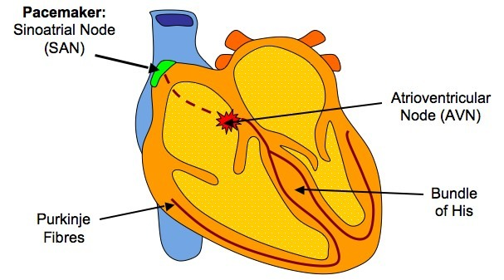
The pacemaker is under autonomic control from the brain, specifically the cardiovascular center in the medulla oblongata (brain stem)
- Sympathetic nerves (also called accelerans) speed up heart rate by releasing a neurotransmitter (noradrenaline) to increase the rate of myocardial contraction
- Parasympathetic nerves (vagus) slow down heart rate by releasing a neurotransmitter (acetylcholine) to decrease the rate of myocardial contraction
- Additionally, the heart rate may be increased by the chemical release of the hormone adrenaline or epinephrine into the blood (from the adrenal gland) – called the “fight or flight” hormone
- Cardiovascular center receives inputs from receptors that monitor blood pressure, blood pH (CO₂ concentration) and oxygen concentration: low blood pressure, low oxygen concentration and low pH signal heart to speed up (deliver more oxygen and remove more CO₂); high blood pressure, high oxygen concentration, high pH signal heart to slow down
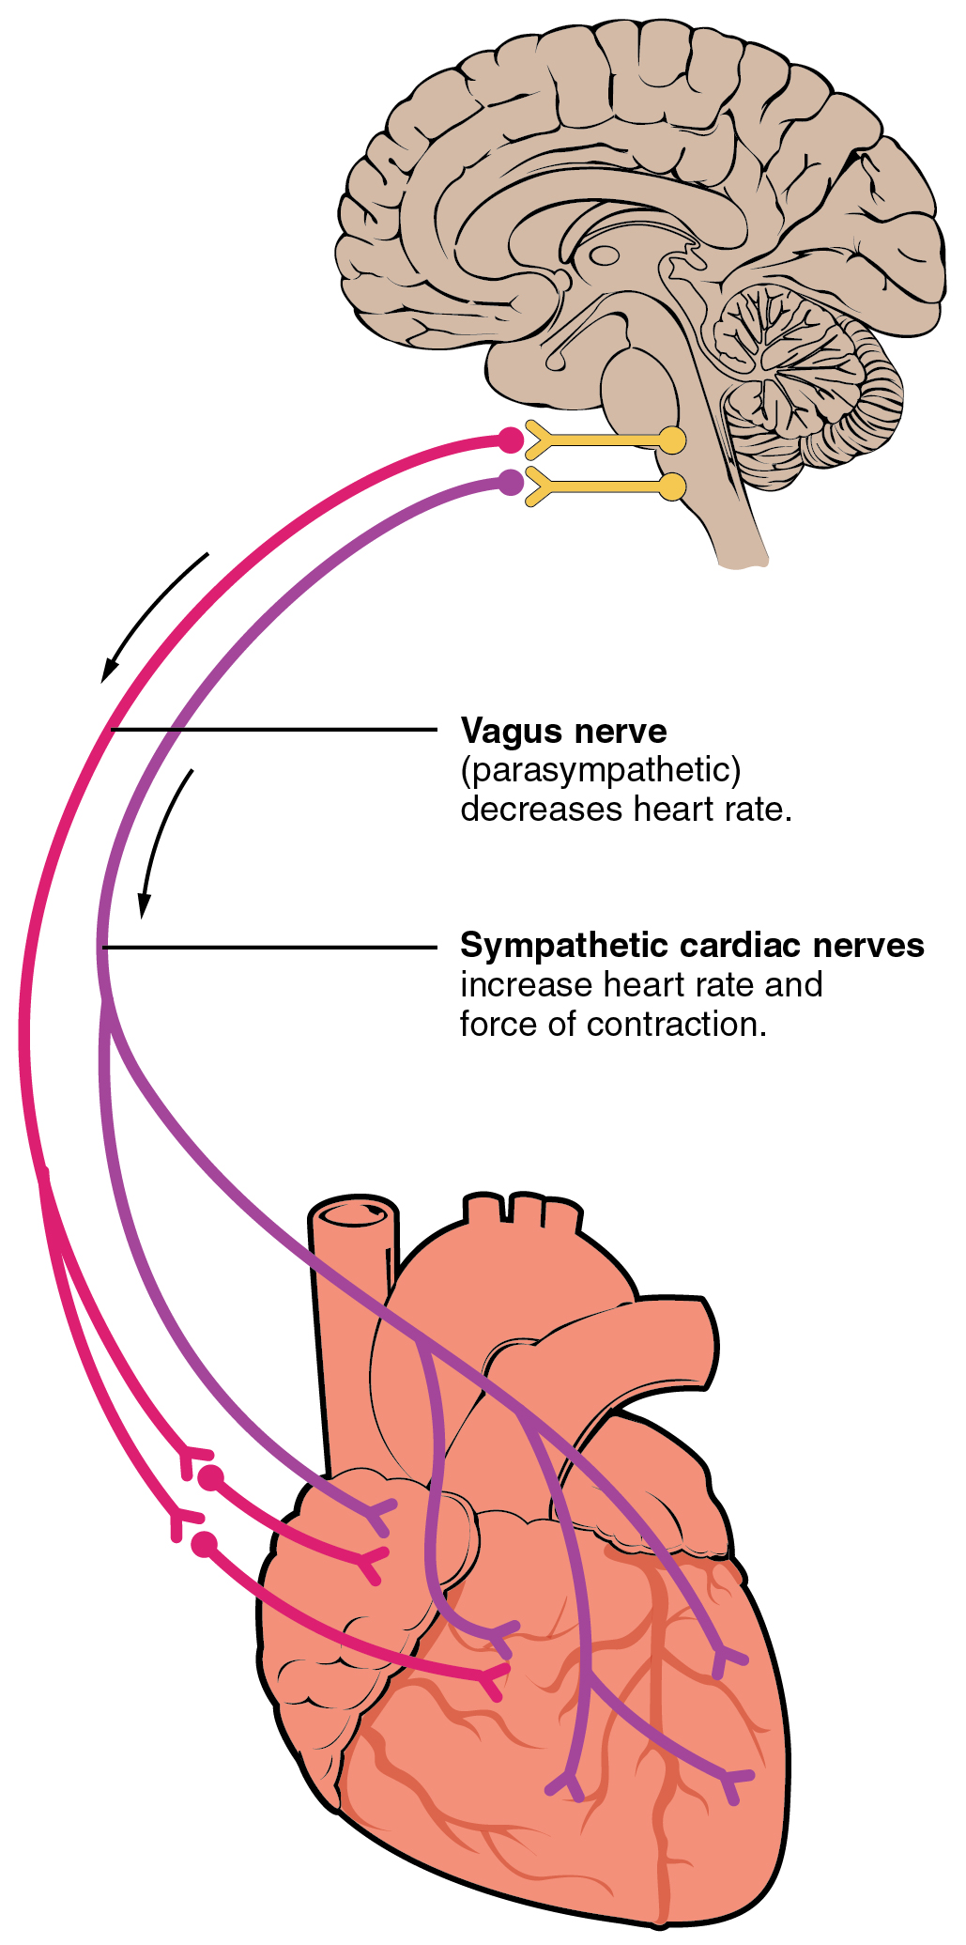
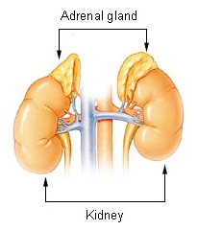

Blood is composed of plasma, erythrocytes, leukocytes (phagocytes and lymphocytes) and platelets
- Plasma - the fluid medium of the blood
- Erythrocytes - red blood cells (involved in oxygen transport)
- Leukocytes - white blood cells, such as phagocytes (non-specific immunity) and lymphocytes (specific immunity)
- Platelets - responsible for blood clotting (hemostasis)
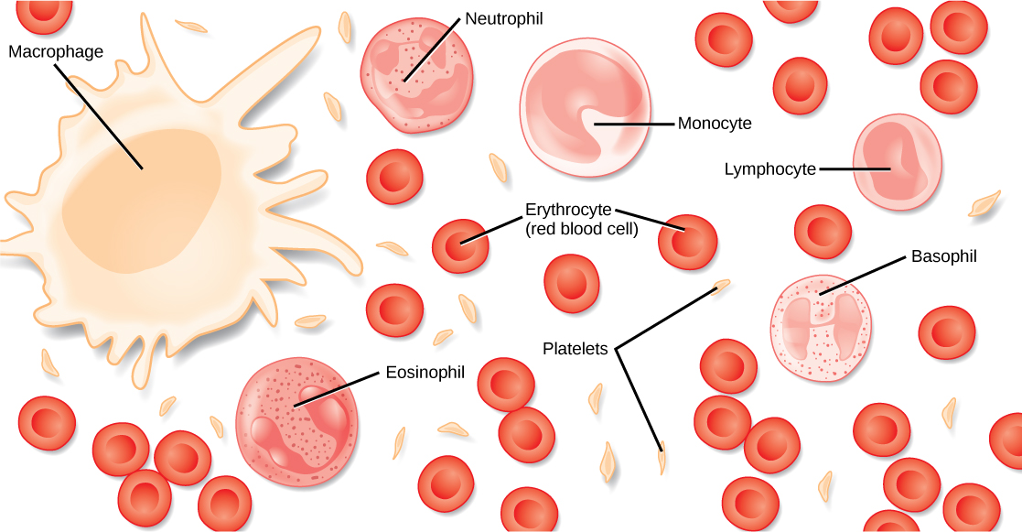
The following are transported by blood: nutrients, oxygen, carbon dioxide, hormones, antibodies, urea and heat
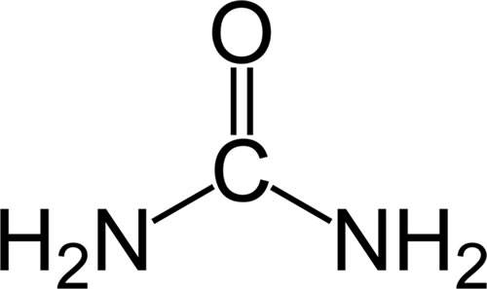
- Nutrients (e.g. glucose)
- Antibodies
- Carbon dioxide
- Hormones
- Oxygen
- Urea
- Heat (not a molecules, unlike all the others)

