The heart provides the pumping power for the circulatory system. It is about the size of a fist and is located approximately between the second and fifth ribs.

Part A Using Figure 8 on page 295 from the textbook plus the internet, label the external and internal views of the heart.

- External View of the Heart

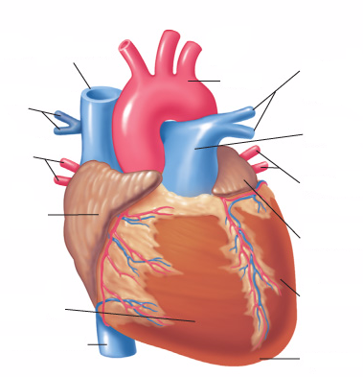

- Internal View of the Heart

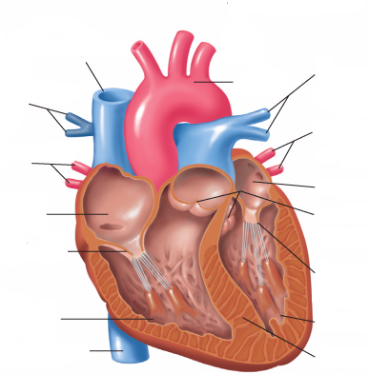

Part B Describe the function of each the heart structures listed below.

Heart Structure | Function of Heart Structure
Right and left atria (singular: atrium)
Right and left ventricles
Septum
Superior vena cava
Inferior vena cava
Pulmonary arteries
Pulmonary veins
Aorta
Tricuspid valve
Bicuspid valve
Semilunar valves

