Name: ___________________________________

Ecosystem Productivity

Ecosystems can be thought of as the biological portion of the carbon cycle. Any flux of carbon, oxygen, water and other nutrients in this biological cycle is accompanied by a change in energy. Figure 1 below shows an ecological pyramid for a simplified food web, and the carbon/energy changes that occur in this web are represented in figure 2.
The biological carbon cycle depends on photosynthesis and respiration. In photosynthesis, producers, green plants and algae, combine carbon dioxide and water to produce carbohydrates and oxygen. The producers use these carbohydrates as an energy source to carry out all of their life activities. To do this, they carry out cellular respiration, the biochemical process in which oxygen is used to break down carbohydrates, releasing energy, water and carbon dioxide. Consumers also use cellular respiration to obtain the energy they need to carry out their life activities. Thus, the complementary processes of photosynthesis and respiration cycle carbon through the living world.
Photosynthesis is an energy storing process in which energy of sunlight is converted into chemical energy. The rate at which the producers convert solar energy to chemical energy is called the
Gross Primary Productivity of an ecosystem. Producers use most of this energy for themselves: the energy remaining after producer respiration and available for all the consumers in an ecosystem is called the Net Primary Productivity. Consumers cannot make their own food: therefore the net productivity is entirely dependent on the producers. However, both consumers and producers carry out respiration, so the total respiration of the ecosystem includes that of the producers and consumers.

Deer
CHO- Organic Carbon Compounds
Atomosphere
Plants
Wolves
Dead Tissue
CO₂
(decomposers)
CO₂
CO₂
(Photosynthesis)
CO₂
CO₂
CHO
CHO
O₂
O₂
CHO
CHO
O₂
PLANT LIFE
(forest)
DEER
WOLVES

Figure 1
CHO

Figure 2

Activity:
Calculate the missing values in the table “Productivity and Respiration in Three Ecosystems” table on the next page. Then answer the discussion questions.

Productivity and Respiration in Three Theoretical Ecosystems
all values in kilocalories/meter2/year

Productivity and Respiration | Alfalfa Field | Short-Grass Prairie | Deciduous Forest
Gross Primary Productivity  (GPP) | 24,000 | 5,230 | 27,976
Plant Respiration (Rp) | 9,200 | 1,778 | 18,200
Net Primary Productivity
(NPP)
Consumer Respiration (Rc) | 800 | 2,379 | 9,172
Net Ecosystem Productivity
(NEP)
Net Ecosystem Respiration (R)

Growth Efficiency
GPP/R

Useful formulas:
Net Primary Productivity (NPP) = Gross Primary Productivity (GPP) - Plant Respiration (Rp)
Net Ecosystem Productivity (NEP) = NPP - Consumer Respiration (Rc)
Net Ecosystem Respiration (R) = Rp + Rc

1. Which ecosystem has the greatest gross primary productivity?
…..the greatest net primary productivity?
…..the greatest net ecosystem productivity?

2. Which ecosystem has the highest ratio of productivity to respiration?

….has the lowest?

What does a ratio of 1.0 mean?

EQUATIONS

Net Primary Productivity (NPP) = Gross Primary Productivity (GPP) – Plant Respiration (R_{p})
Net Ecosystem Productivity NEP = NPP – Consumer Respiration (R_{c})
Net Ecosystem Productivity NEP = GPP – R
Net Ecosystem Respiration (R) = R_{p} + R_{c}
% Trophic Level Efficiency = (Production_{(higher level)} / Consumption_{(higher level)} ) * 100
% Growth Efficiency = ( Production / Consumption ) * 100

Using the food chain shown below, answer the following questions.
BE SURE TO USE COMPLETE UNITS THROUGHOUT YOUR EQUATIONS!!!

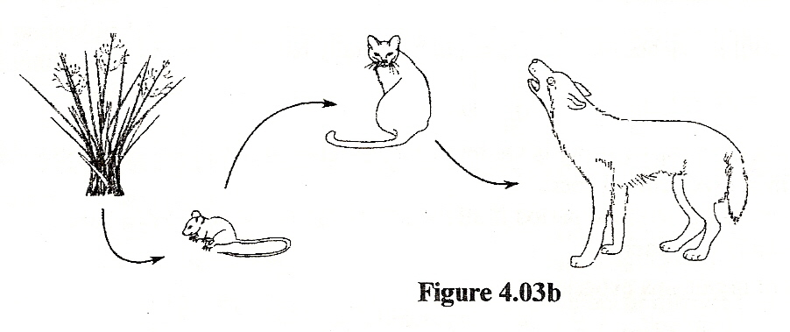
- Calculate the net primary productivity if the gross productivity of the grasses is 500,000 kJ/m²/yr and their annual respiration is 340,000 kJ/m²/yr.

- Calculate the net ecosystem productivity if the gross productivity of the grasses is 500,000 kJ/m²/yr and the ecosystem organisms’ respiration rates are as follows:

Grasses: 340,000 kJ/m²/yr
Mice: 80,000 kJ/m²/yr
Cats: 60,000 kJ/m²/yr
Wolves: 40,000 kJ/m²/yr

- What does your answer to the previous question say about the ecosystem? What’s happening to it?

- Explain how there can be two equations for NEP in the box above.

- Calculate the % trophic level efficiency of the wolves if the productivity of the cats eaten by the wolves is 96,000 kJ/m²/yr and the productivity of the wolves is 9,000 kJ/m²/yr.

- What is the % growth efficiency of the mouse population in this ecosystem if they consume 50,800 kJ/m2/yr of grass and grow (produce) 1500 kJ/m2/yr?

Here are some typical organic materials in an ecosystem and their energy content per gram:

Organic Material | Energy Content (kJ/g)
Fat | 38
Muscle | 25
Vegetation | 21
Roots | 19
Wood | 17

We can calculate the energy content of everything in an ecosystem.

1. What is the energy content of a tree that weighs 250 kg and is composed of 30% roots and 70% wood?

2. If the production of herbivorous rabbits is 1100kJ/m²/year, and the production of the grasses they feed upon annually is 12,000 kJ/m², then what is the % trophic level efficiency?

3. The biological production and biomass at each higher tropic level decreases. What factors account for this?

